# Department of Computing

**CS-213: Advanced Programming**

**Class: BSCS 7AB**

# Lab 3: jQuery

**Date: 19 September, 2019**

**Time: 10:00-01:00pm & 02:00-05:00pm**

# Instructor: Dr. Sidra Sultana

**Lab Engineer: Ms. Ayesha Asif**

**Submitted by: Muhammad Tayyab**

**217038**

**BSCS7B**

# 

# Lab 3: jQuery

**Introduction**

JQuery is a widely used and well-known library for JavaScript which helps in rapid web development. Most of the modern websites use jQuery as a tool to implement and control client side dynamic behavior of the websites. Students have learned basic and advanced concepts of jQuery during lectures. This lab will help them to further understand these concepts by practically using jQuery in given situations.

**Objectives**

The objective of this lab is helping students to familiarize themselves with basic and advanced concepts of jQuery by practically implementing them in given scenarios. The knowledge students have gained in the lectures will help them to develop and control dynamic behavior of web pages using jQuery.

**Tools/Software Requirement**

Notepad, DreamWeaver, browser.

**Helping Material:**

W3Schools: <https://www.w3schools.com/js/default.asp>

jQuery API: <http://api.jquery.com/>

jQuery Cheatsheet: <https://oscarotero.com/jquery/>

**Lab Tasks**

**Task 1**

A basic version of lab is given in ‘grocery-basic-skeleton.html’ file along with CSS and JavaScript (see ‘lab-3-supporting-material.zip’). Using jQuery, you have to change the behavior of the list items <li> as explained below:

1. When you click on any list item <li>, it should display current date and time in the format shown in the image below.

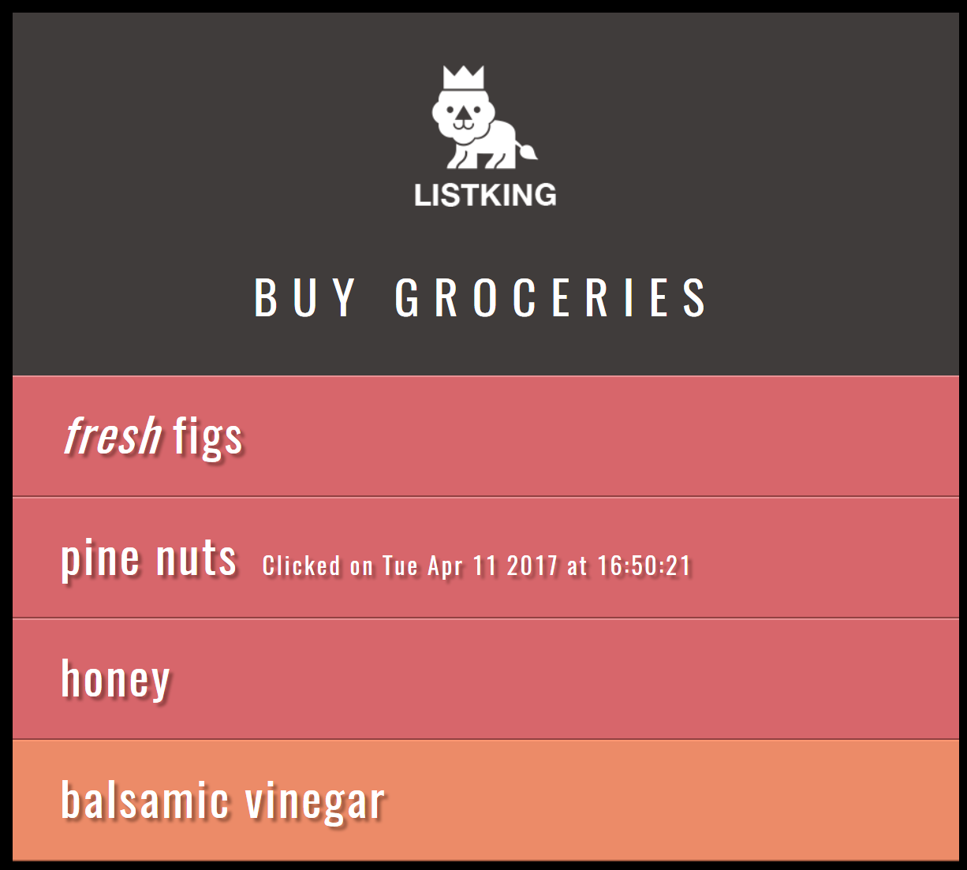

1. Hint: A <span> class ‘date’ is already defined in CSS. You can use it to style date and time.

**Task 2**

Using the ‘grocery-basic-skeleton.html’ file, you have to change the behavior of the list items (using jQuery) as explained below:

1. Add a new paragraph after last list item as shown below:

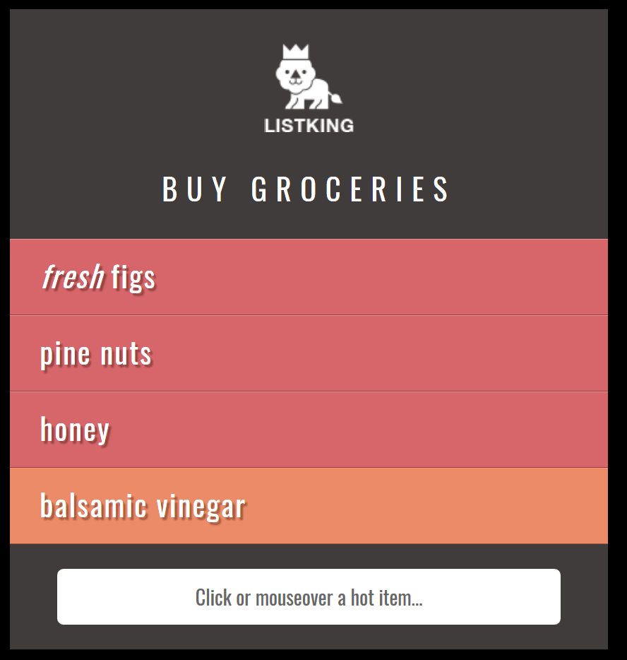

1. When you click or mouse over on any list item <li>, it should display following information:
   1. Item: Name of list item which is clicked or on which mouse over event occurred
   2. Status: Important (for honey and pine nuts), Available (for all other items)
   3. Event: Name of event (click, mouseover)

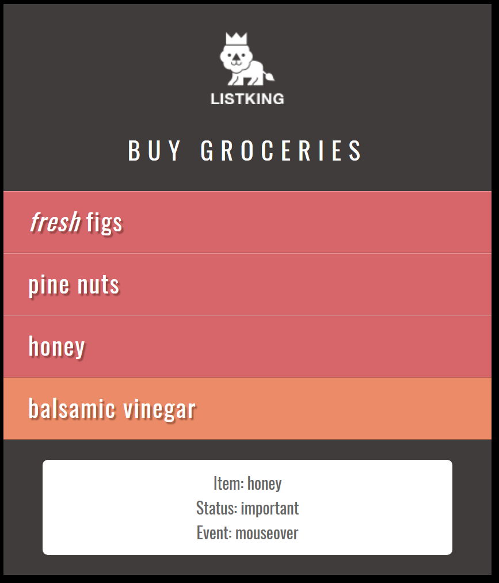

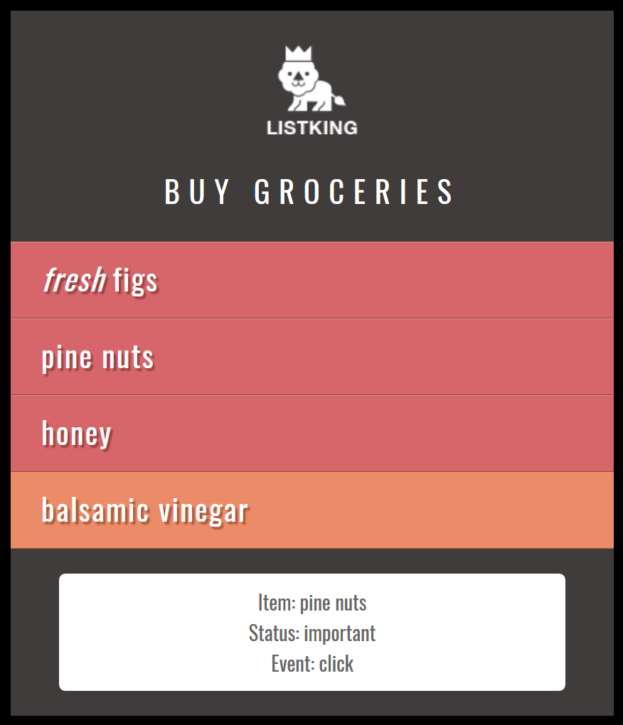

**Task 3**

1. Extend the ‘basic-skeleton.html’ file but adding new list items and a footer as shown below (hint: use MS word’s zooming to clearly see the figure):

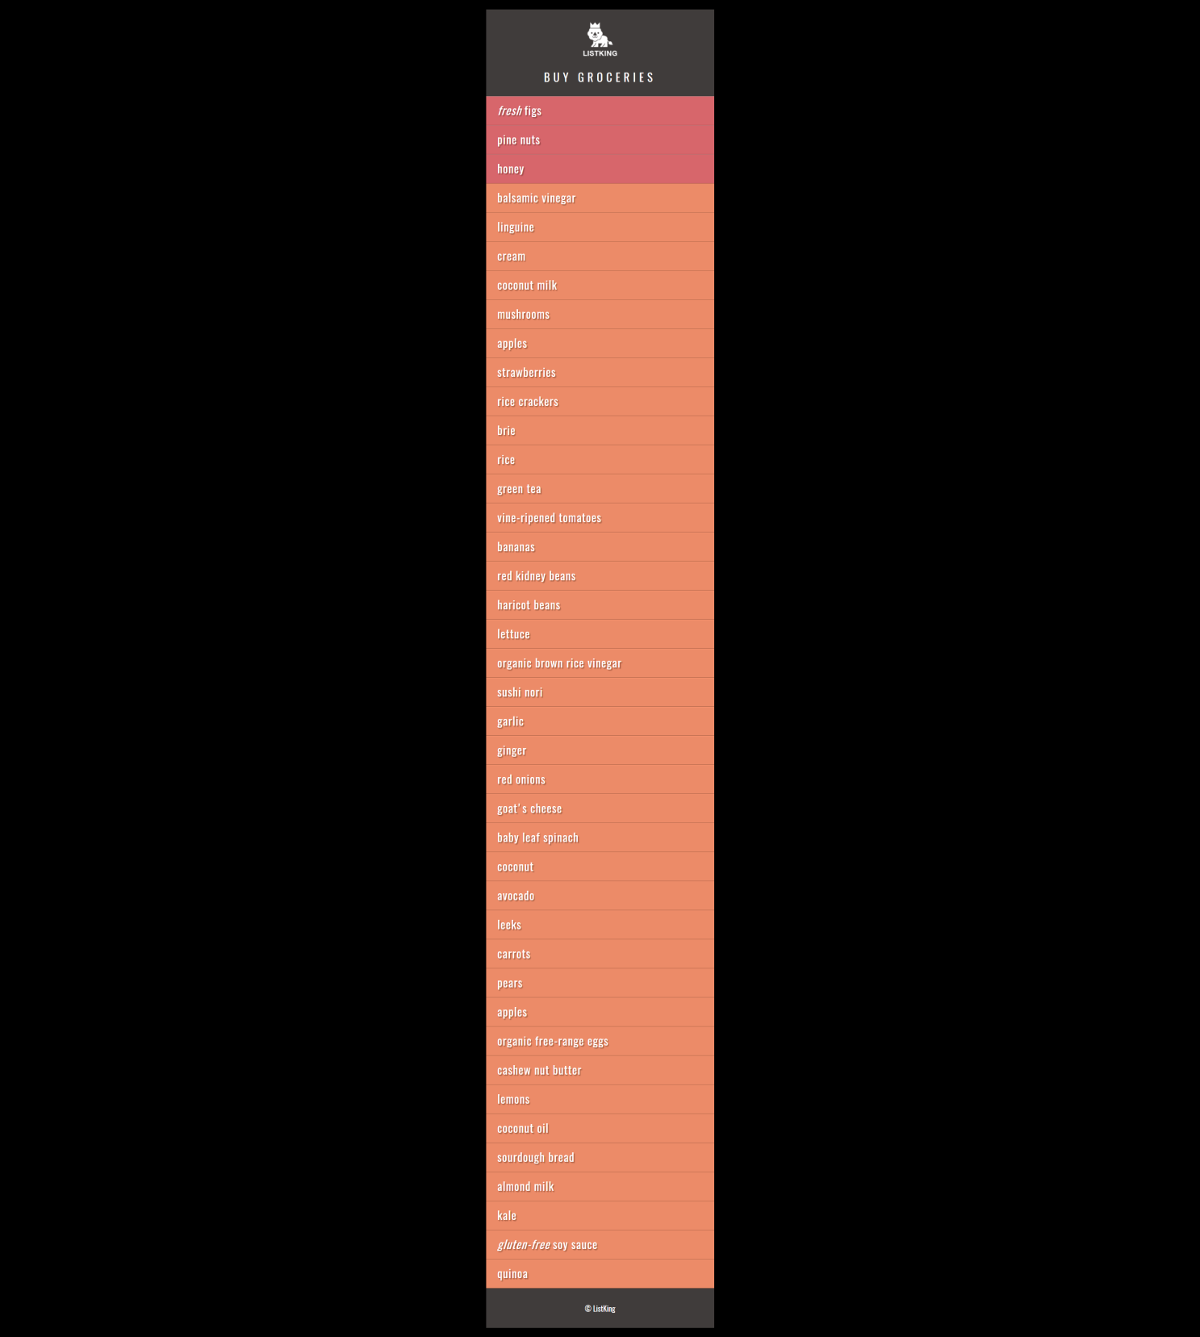

1. When scroll the page down to bottom, a new div appears at the bottom-right side, showing latest promotions:

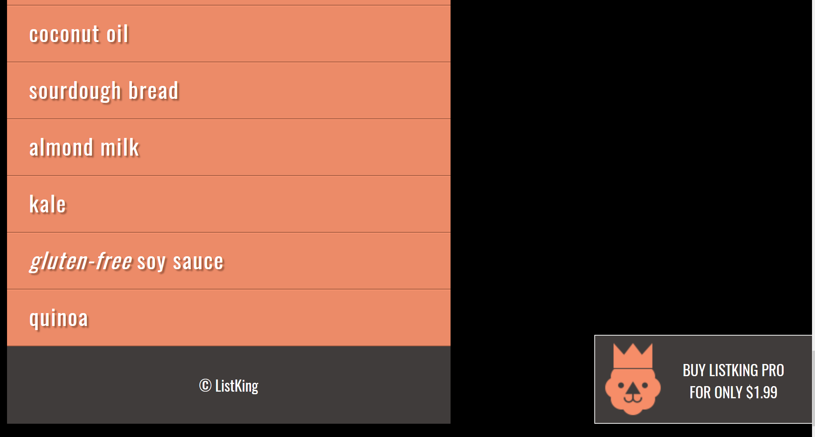

1. The promotion div must disappear as soon as the user scrolls the page up to 500px from the bottom.

**Hints:**

* Use $window.scrollTop() to get the current vertical position of the scroll bar.
* Use following formula to find if the user is within bottom 500px of the page.
  + $('#footer').offset().top - $window.height() – 500
* Use $window.on (‘scroll’, function(){….} to handle onScroll() event of the window.
* jQuery’s animate() function will help you achieving this task.

|  |
| --- |
| Solution |
| Task 1 Code:  <!DOCTYPE html>  <html>  <head>  <title>JavaScript &amp; jQuery - Chapter 7: Introducing jQuery - Event Object</title>  <link rel="stylesheet" href="css/c07.css" />  <script src="https://ajax.googleapis.com/ajax/libs/jquery/3.4.1/jquery.min.js"></script>  </head>  <body>  <div id="page">  <h1 id="header">List</h1>  <h2>Buy groceries</h2>  <ul>  <li id="one" class="hot"><em>fresh</em> figs </li>  <li id="two" class="hot">pine nuts </li>  <li id="three" class="hot">honey </li>  <li id="four">balsamic vinegar </li>  </ul>  </div>  <script>  var date = new Date();  var weekdays = new Array(7);  weekdays[0] = "Sun";  weekdays[1] = "Mon";  weekdays[2] = "Tue";  weekdays[3] = "Wed";  weekdays[4] = "Thur";  weekdays[5] = "Fri";  weekdays[6] = "Sat";  var day = weekdays[date.getDay()];  var dateTime = "Clicked on " + day + " " + date.getMonth() + " " + date.getDate() + " " + date.getFullYear() + " at " +  date.getHours() + ":" + date.getMinutes() + ":" + date.getSeconds();  $(document).ready(function(){  $("li").click(function(){  var d= new Date();  $(this).append("<span>" +dateTime+ "</span>");  });  });  </script>    </body>  </html>  Task 1 Output Screenshot:    Task 2 Code:  <!DOCTYPE html>  <html>  <head>  <title>JavaScript &amp; jQuery - Chapter 7: Introducing jQuery - Event Object</title>  <link rel="stylesheet" href="css/c07.css" />  <script src="https://ajax.googleapis.com/ajax/libs/jquery/3.4.1/jquery.min.js"></script>  </head>  <body>  <div id="page">  <h1 id="header">List</h1>  <h2>Buy groceries</h2>  <ul>  <li id="one" class="hot"><em>fresh</em> figs <span > </span> </li>  <li id="two" class="hot" value="1" >pine nuts <span> </span> </li>  <li id="three" class="hot" value="1" >honey <span> </span> </li>  <li id="four">balsamic vinegar <span> </span> </li>  <p >Click or mouseover an item</p>  </ul>  </div>  <script>  $(document).ready(function(){  $("li").click(function(){  var txt = "Item: "+$(this).text();  if ($(this).val() == 1) {  $("p").html(txt + "<br>Status: Important <br>Event: Click");    }  else {  $("p").html(txt + "<br>Status: Avaliable <br>Event: Click");  }  });  $("li").mouseover(function(){  var txt = "Item: "+$(this).text();  if ($(this).val() == 1) {  $("p").html(txt + "<br>Status: Important <br>Event: Mouseover");    }  else {  $("p").html(txt + "<br>Status: Avaliable <br>Event: Mouseover");  }  });  });  </script>    </body>  </html>  Task 2 Output Screenshot:    Task 3 Code:  <!DOCTYPE html>  <html>  <head>  <title>JavaScript &amp; jQuery - Chapter 7: Introducing jQuery - Event Object</title>  <link rel="stylesheet" href="css/c07.css" />  <script src="https://ajax.googleapis.com/ajax/libs/jquery/3.4.1/jquery.min.js"></script>  </head>  <body>  <div id="page">  <h1 id="header">List</h1>  <h2>Buy groceries</h2>  <ul>  <li id="one" class="hot"><em>fresh</em> figs <span > </span> </li>  <li id="two" class="hot" value="1" >pine nuts <span> </span> </li>  <li id="three" class="hot" value="1" >honey <span> </span> </li>  <li id="four">balsamic vinegar <span> </span> </li>  <li>linguine</li>  <li>cream</li>  <li>coconut milk</li>  <li>mushrooms</li>  <li>apples</li>  <li>strawberries</li>  <li>rice crackers</li>  <li>brie</li>  <li>rice</li>  <li>green tea</li>  <li>vine-ripened tomatoes</li>  <li>bananas</li>  <li>red kindey beans</li>  <li>haricot beans</li>  <li>lettuce</li>  <li>organice brown rice vineager</li>  <li>sushi nori</li>  <li>garlic</li>  <li>ginger</li>  <li>red onions</li>  <li>goat's cheese</li>  <li>baby leaf spanich</li>  <li>coocnut</li>  <li>avocado</li>  <li>leeks</li>  <li>carrots</li>  <li>pears</li>  <li>apples</li>  <li>goat's cheese</li>  <li>baby leaf spanich</li>  <li>coocnut</li>  <li>avocado</li>  <li>leeks</li>  <li>carrots</li>  <li>pears</li>  <li>apples</li>  <li>quinoa</li>  </ul>  <h2 id="footer">&#169;List King</h2>  </div>  <div id='slideAd'>  <center>BUY LISTKING PRO<br>FOR ONLY $1.99</center>  </div>  <script>  slided = false;  $(window).on('scroll', function(){  if($(window).scrollTop() + $(window).height() == $(document).height()) {  $("#slideAd").animate({right: '0px'});  slided = true;  }  if($(window).scrollTop() < $('#footer').offset().top - $(window).height() - 500 && slided == true){  $("#slideAd").animate({right: '-230px'});  slided = false  }  });  </script>    </body>  </html>  Task 3 Output Screenshot: |

### Deliverables

Compile a single word document by filling in the solution part and submit this Word file on LMS. This lab grading policy is as follows: The lab is graded between 0 to 10 marks. The submitted solution can get a maximum of 5 marks. At the end of each lab or in the next lab, there will be a viva related to the tasks. The viva has a weightage of 5 marks. Insert the solution/answer in this document. You must show the implementation of the tasks in the designing tool, along with your complete Word document to get your work graded. You must also submit this Word document on the LMS. In case of any problems with submissions on LMS, submit your Lab assignments by emailing it to Ms. Ayesha Asif: [ayesha.asif@seecs.edu.pk](mailto:ayesha.asif@seecs.edu.pk).